**Lab Report # 05**



**CSE301 - L Signals & Systems Lab**

Submitted by: AWAIS SADDIQUI

Registration No: 21PWCSE1993

Class Section: “A”

Submitted to:

**Dr. Durr-e-Nayab**

**Department of Computer System Engineering**

**UET Peshawar**

**301L: Signals & Systems Lab**

**LAB ASSESSMENT RUBRICS**

|  |  |  |  |  |
| --- | --- | --- | --- | --- |
| **Marking Criteria** | **Exceeds expectation (5-4)** | **Meets expectation** **(3-2)** | **Does not meet expectation (1)** | **Score** |
| **1. Realization of Experiment** | Program compiles (noerrors and no warnings).  Program always works correctly and meets the specification(s).  Completed between 71-100% of the requirements. | Program compiles (no errors and some warnings).  Some details of the program specification are violated, program functions incorrectly for some inputs.  Completed between 41-70% of the requirements. | Program fails to or compile with lots of warnings.  Program only functions correctly in very limited cases or not at all.  Completed less than  40% of the requirements. | 30% |
| **2. Ability to apply required code utility or data structure** | Able to apply required data type or data structure and produce correct results. Familiarize and selects proper functions for simulation of given problem using  software tools like  MATLAB. | Able to apply required data type or data structure but does not produce correct results. Need guidance to select proper functions for simulation of given problem using  software tools like  MATLAB. | Unable to identify required data type or data structure.  Incapable of selecting proper functions for simulation of given problem using software tools like MATLAB. | 20% |
| **3. Documentation** | Clearly and effectively documented including descriptions of all variables/functions. Specific purpose is noted for each function, control structure, input requirements and output results. | Basic documentation including descriptions of all variables/functions. Specific purpose is noted for each function and control structure. | No documentation included. | 10% |
| **4. Ability to run/debug** | Executes Matlab codes without errors, excellent user | Executes Matlab codes without errors.  User prompts are | Does not execute Matlab codes due to errors. | 20% |

|  |  |  |  |  |
| --- | --- | --- | --- | --- |
|  | prompts, good use of symbols, spacing in output.  Thorough and organized testing has been completed and output from test cases is included. | understandable, minimum use of symbols or spacing in output.  Some testing has been completed. | User prompts are misleading or nonexistent.  No testing has been completed. |  |
| **5. Results compilation** | Show processed results effectively by conducting simple computations and plotting using collected data | Show processed results effectively by conducting simple computations and plotting using collected data with minor error | Unable to show processed results effectively by conducting simple computations and plotting using collected data with minor error | 10% |
| **6. Efficiency** | Excellent use of CPU and Memory. | Good but not smart use of CPU and Memory. | Inefficient use of CPU and Memory. | 10% |
| **7. Lab**  **Performance (Team work and Lab**  **etiquettes)** | Actively engages and cooperates with other group members in an effective manner. Respectfully and carefully observes safety rules and procedures | Cooperates with other group members in a reasonable manner. Observes safety rules and procedures with minor deviation. | Distracts or discourages other group members from conducting the experiment. Disregards  safety rules and procedures. | 10% |

**Instructor:**

Name: _________________________

Signature: ______________________

**Signals & Systems Laboratory**

**COMPLEX NUMBERS:**

Complex numbers are numbers that are composed of a real part and an imaginary part, written in the form of “a+bi”, where a and b are real numbers and i is the imaginary unit, defined as the square root of -1. The real part of a complex number represents the horizontal axis on the complex plane, while the imaginary part represents the vertical axis. The complex plane is a 2-dimensional plane in which complex numbers can be plotted as points.

**COMPLEX EXPONENTIAL SIGNALS**

A complex exponential signal is a signal of the form x(t) = Ae^(j*omega*t), where “A” is the amplitude, “omega” is the frequency, “t” is time, and “j”=sqrt{-1} is the imaginary unit. The signal is said to be complex because it has both real and imaginary components, and exponential because it has a constant base raised to a time-varying exponent.

**OBJECTIVES OF THE LAB**

* Gain familiarity with Complex Numbers and plot them
* Complex exponential signals
* Real exponential signals

**TASK 01**

**Write MATLAB function zprint, which takes a complex number and returns it real part, imaginary part, magnitude, phase in radians, and phase in degrees**

**CODE:**

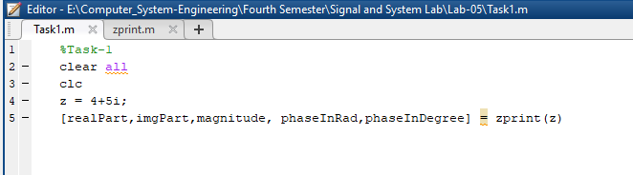

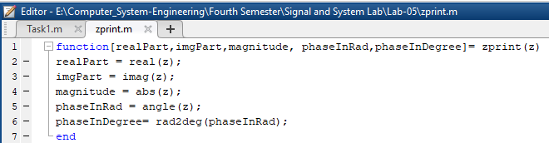

**OUPUT:**

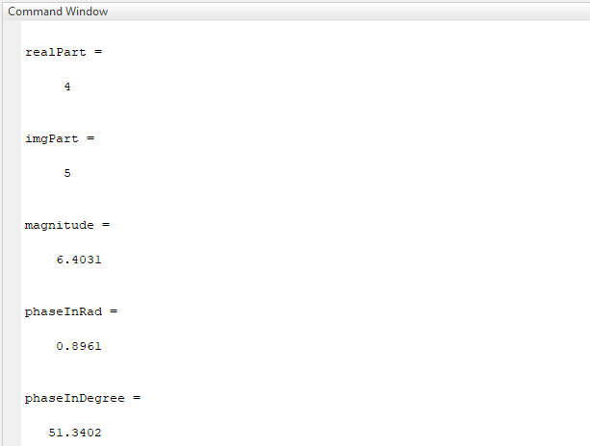

**TASK 02**

**Compute the conjugate ź (i.e. z_conj [give variable name]) and the inverse 1/z (i.e. z_inv [give variable name]) for any complex number z. Display the results numerically with zprint.**

**CODE:**

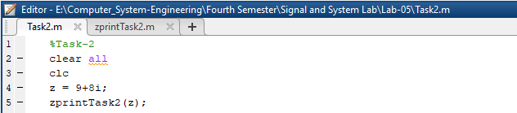

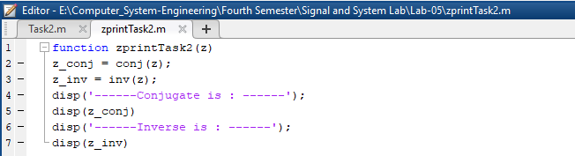

**OUPUT:**

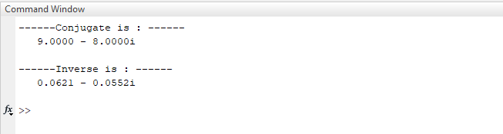

**TASK 03**

**Take two complex number and compute z1 +z2 and display the results numerically using zprint.**

**CODE:**

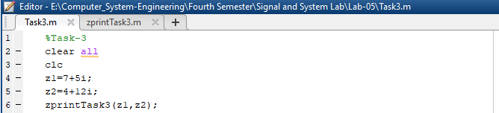

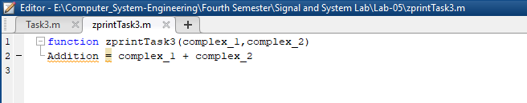

**OUPUT:**

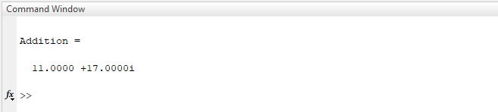

**TASK 04**

**Take two complex numbers and compute z1z2 and z1/z2. Use zprint to display the results numerically.**

**CODE:**

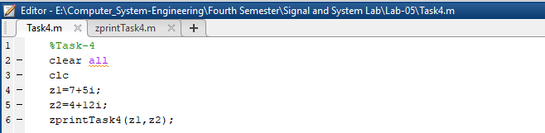

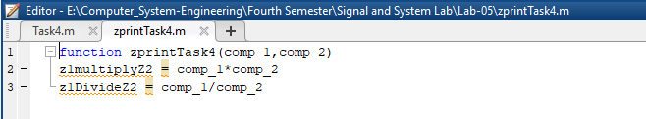

**OUPUT:**

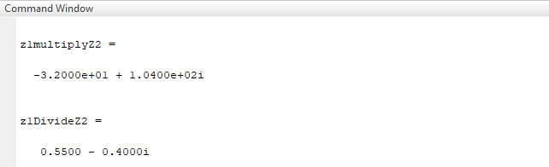

**TASK 05**

**Determine the complex conjugate of the exponential signal given in above example and plot its real and imaginary portions.**

**CODE:**

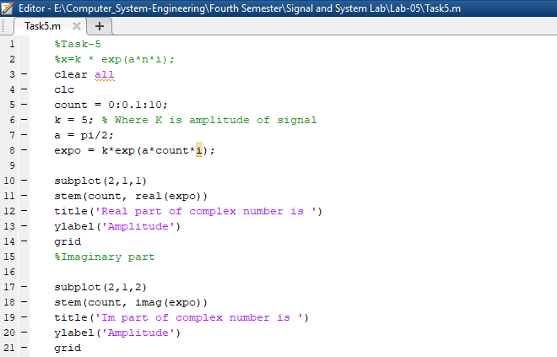

**OUPUT:**

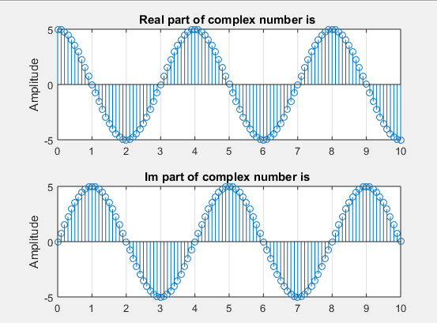

**TASK 06**

**Generate the complex valued signal and plot its magnitude, phase, the real part, and the imaginary part in separate subplots.**

**CODE:**

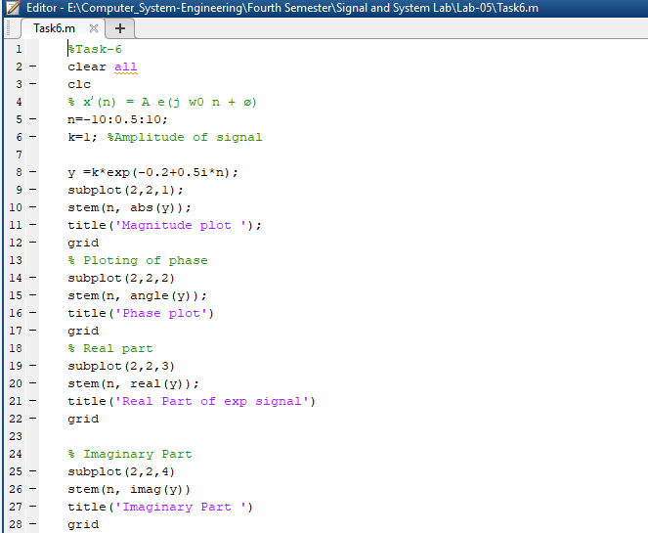

**OUPUT:**

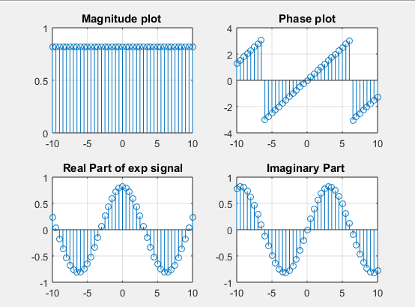

**TASK 07**

**Generate a real‐exponential x=a * exp (n) for a=0.7 and n ranging from 0‐10. Find the discrete time as well as the continuous time version of this signal. Plot the two signals on same graph (holding both the graphs).**

**CODE:**

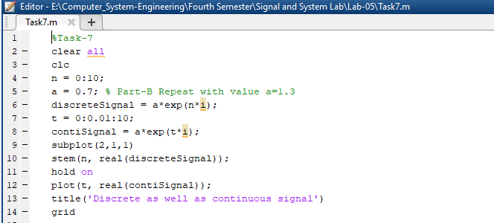

**OUPUT:**

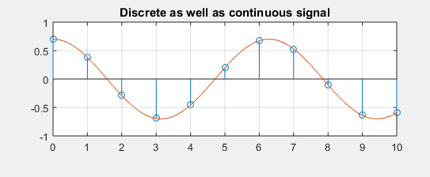

**TASK 08**

**Multiply the two discrete signals x1=5 exp (i*n*pi/4) and x2= a * exp(n) (use point‐by‐point multiplication of the two signals). Plot the real as well as the exponential parts.**

**CODE:**

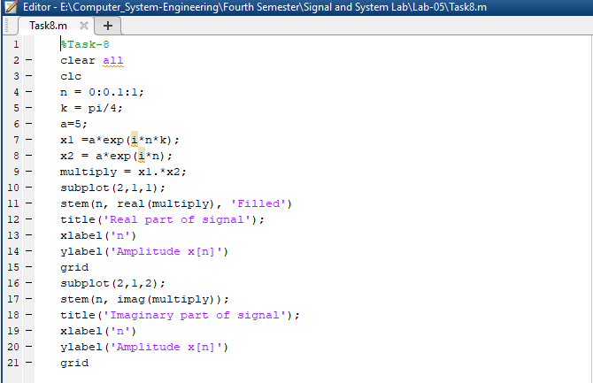

**OUPUT:**

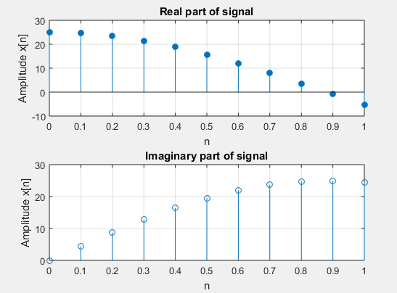

**TASK 09**

**Plot the discrete signal x=a^|n| for n ranging from ‐10 to 10. Draw two subplots for 0<a1**

**CODE:**

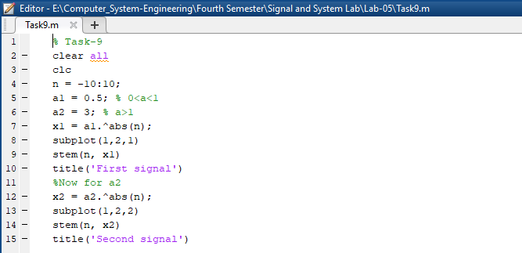

**OUPUT:**

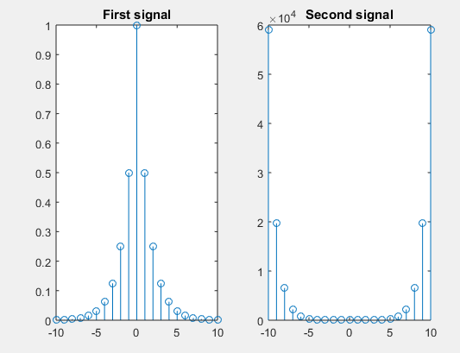

**TASK 10**

**Generate the signal x(t) = Ae(jωt + π) for A = 3, π= ‐0.4, and ω = 2π(1250). Take a range for t that will cover 2 or 3 periods.**

**CODE:**

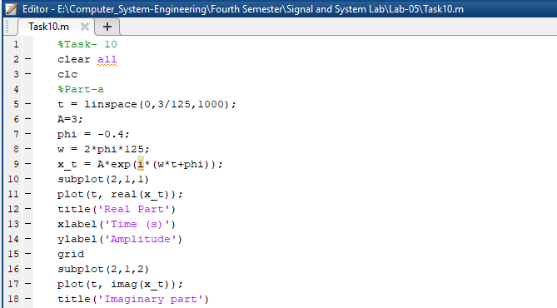

**OUPUT:**

